BACK END

- Display ‘Expiration Date’ (in addition to, or instead of ‘Date Added’)
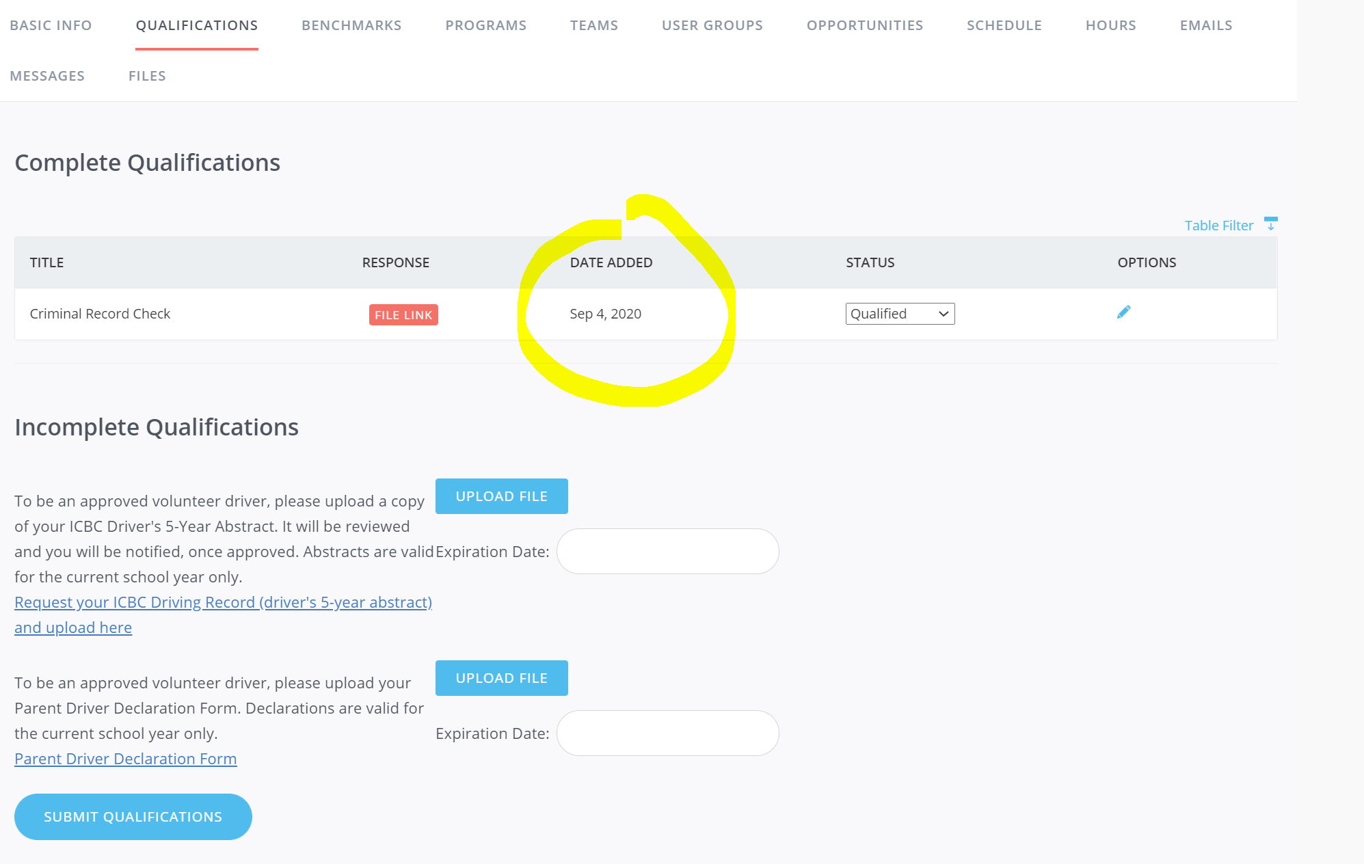

FRONT END
My Profile > My Qualifications
- Can you display ‘Expiration Date’ (in addition to, or instead of ‘Date Added’)

