Qualification Expiration Dates

Back End – Manager View

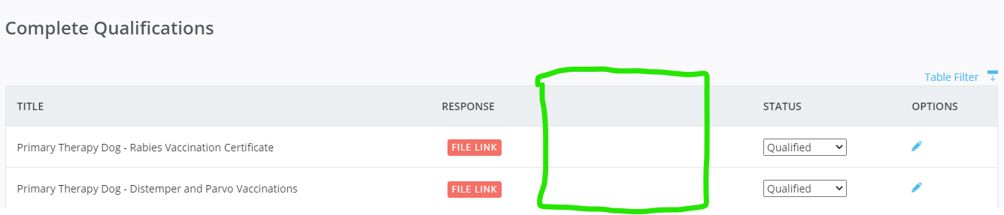

Front End – Volunteer View

